1. **Create 3 ec2-instances and establish ssh password less connection between them.**

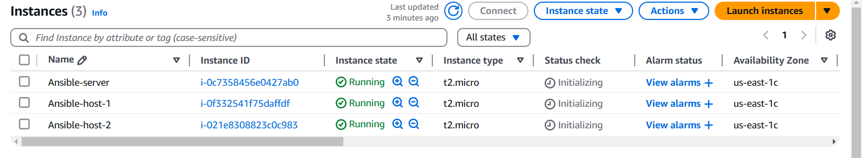

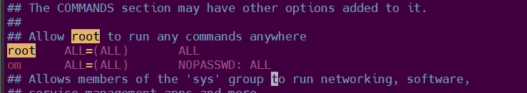

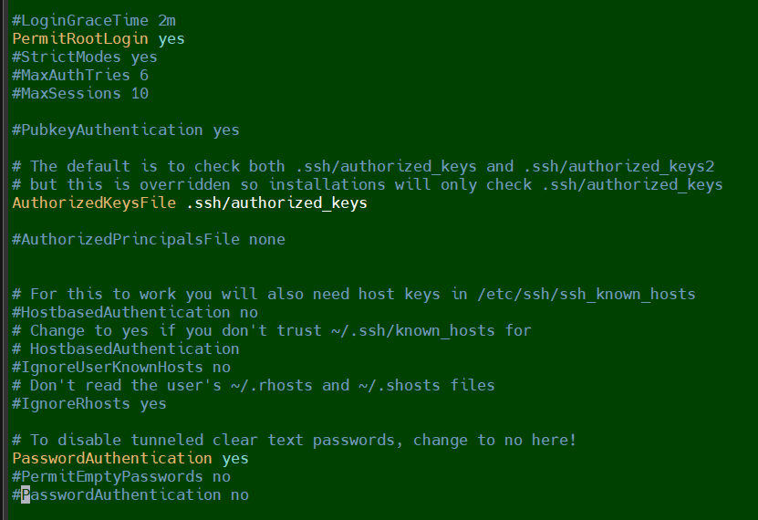

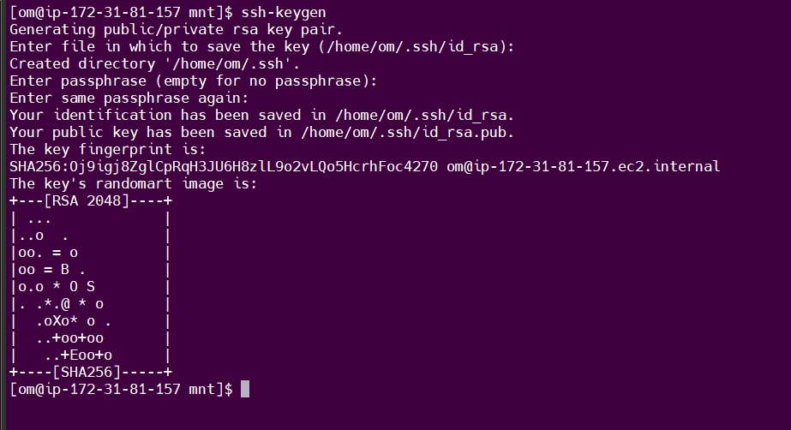

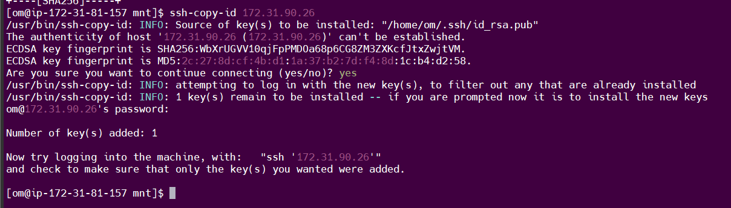

Output -

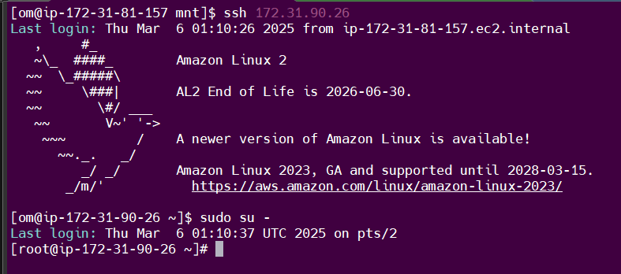

1. **Ansible-server files configuration.**

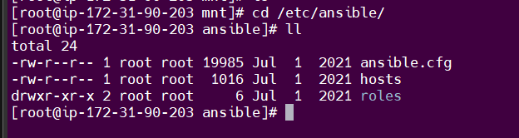

* **ansible.cfg**

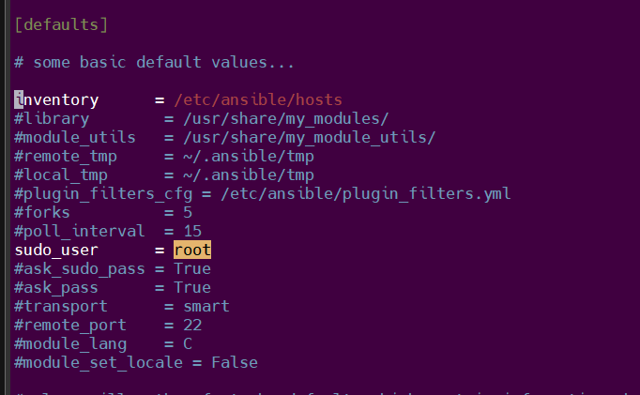

* **hosts,**

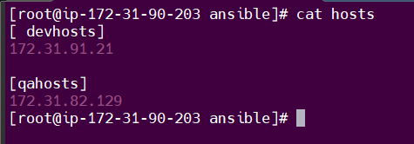

* **commands,**

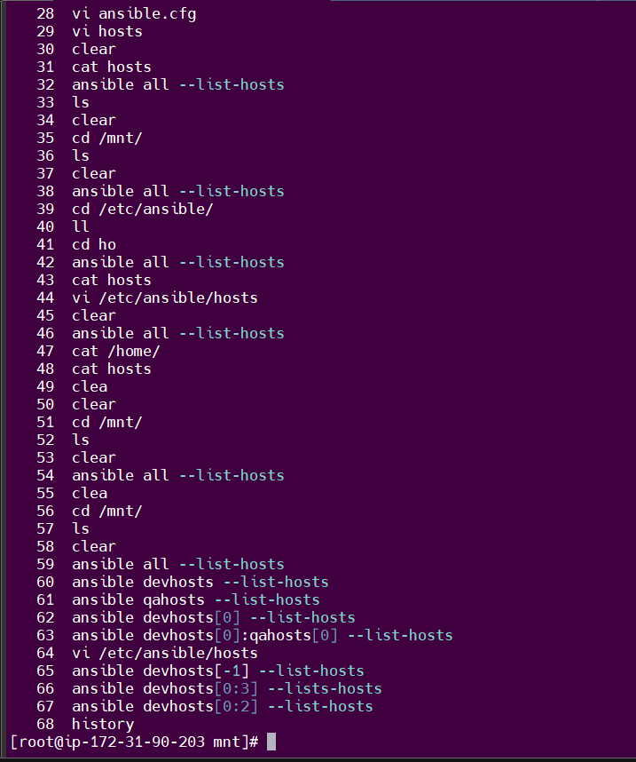

**Assignment 3 - adhoc command with module**